# Lab: Selenium Basics

This document defines the homework assignments from the ["QA Automation" Course @ Software University](https://softuni.bg/trainings/1584/qa-automation-march-2017).

Please submit as homework a single zip / rar / 7z archive holding the source code or whatever approach is needed to finish your tasks. In all tests should be used **Page Object Model** and **3A patterns.**

# Selenium

## Google Search

Write a **test** that **open browser** and navigate to **http://www google.com**. Then **search** for the best browser automation tool "**Selenium**". Click on **first link** and check if browser will open [**http://www.seleniumhq.org**](http://www.seleniumhq.org).

**Assert** that title is "Selenium - Web Browser Automation"**.**

### Examples

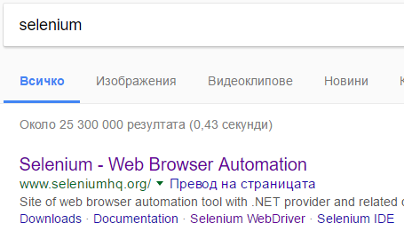

## QA Automation

Write a **test** that **open browser** and navigate to [**http://www.softuni.bg**](http://www.softuni.bg). Then by using **navigation bar** navigate to QA Automation course page.

**Assert** that there are heading tag **<h1>** and that contains **"**QA Automation - януари 2019**"**

### Examples



## Automationpractice registration page

Write a **test** that **navigate** to <http://automationpractice.com/index.php> and navigate to **registration page.**

**Assert** that registration page is open.

### Examples

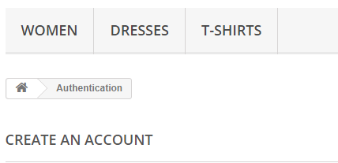

## Automationpractice Registration negative tests

After last test you can be sure that registration page is open correctly. Now for next tests you can navigate directly to <http://automationpractice.com/index.php>**.** Write at least **five negative tests** against registration form. Your tests have to check **five** **different error messages** in the registration form.

### Examples

